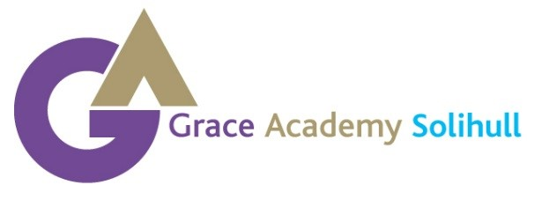

Chapelhouse Road
Chelmsley Wood
Birmingham
B37 5JS
Telephone Number: 0121 329 4600
solihull@graceacademy.org.uk

BIOMETRICS AGREEMENT

Dear Parent or Carer

Biometric Cashless Catering System

This system will enable us to deliver a more efficient and effective catering service for our students, parents and staff, whilst at the same time helping the caterers to continue to provide wholesome, healthy and enjoyable school meals at a reasonable price. In the future, this system has the potential to allow us to enhance and improve the efficiency of our registration, exam entry and library systems.

This biometrics cashless catering system offers many benefits to students, parents and staff and a few are mentioned below:

Students:

- Reduction in queuing times through rapid and more efficient till service.
- Supports healthy eating programmes via a reward/points system.
- Monitors nutritional intake.
- No distinction made between paying students and those entitled to receive Free School Meals.
- Reduction in catering wastage through the use of a pre order facility.

Parents

- Provide parents with a breakdown of what your son/daughter has spent their lunch money on via online payment system.
- Reduced cost, improved administration, efficiency as there is no need to replace lost, damaged or stolen cards.
- Spending controlled by setting daily spending limits for individual pupils.
- Opportunity to sign up to text alerts to top up your son/daughter’s account.

We need your consent to do this, please carefully read the enclosed information then return the signed consent form.

Yours sincerely

Darren Gelder
Principal

SOME KEY QUESTIONS AND ANSWERS ABOUT THE BIOMETRIC CASHLESS CATERING SYSTEM

What is a biometric cashless system?
- A software program which recognises each individual customer, holds individual cash balances and records
expenditure and cash received. It also records where and when money is spent and on what food.

How are students and staff recognised by the system?
- By a biometric measurement which takes a part image of some of the coordinates of the finger. This information is then converted and stored in the system as a unique number.
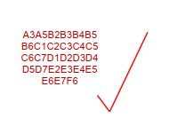
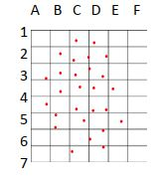
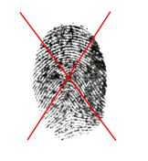

- The image is then removed and only the unique number remains in the system and cannot be converted back into any image of a finger nor can it be used by any other source for identification purposes.

What data will be held on the system?
- Certain data will be held in the system to enable accurate operation. This will include the student's name, tutor group, photo, account balance, meal entitlement and the biometric number. This is not new data. Other than the biometric number, this data is already held on the Academy's administrative systems.

- All the data will be handled under the guidelines of the Data Protection Act. The data will only be utilised for the purposes of the cashless catering system and will be destroyed when the data is no longer relevant (such as when a student leaves the Academy).
How is biometric system utilised to obtain food?
- A finger will be placed on a biometric scanner at a till. This will activate an individual's account which will be displayed on screen for the catering operator. The operator will then enter the selected food and drink into the system from an itemised keyboard, while the amount spent and the new balance will show on the display.

How is money entered into the system?
- By putting cash, notes (£20, £10, £5) and coins (£2, £1, 50p, 20p, 10p), into an automatic cash ‘revaluation' terminals. After activation via a biometric scanner, the terminal will show the current account balance. Cash is then entered and, finally, a red button pressed to mark the end of the transaction.

- By the online payment system (via the Learning Gateway on the academy website). Making payment by debit or card cards (activation letter enclosed).

How is the entitlement to a free school meal handled?
- The system works exactly the same for all students whether they pay themselves or have a free school meal.

- All students gain access to their accounts via the biometric scanners. The amount allocated for a free school meal will be entered into the system daily by the software and will be accessible at break and lunchtime.

- Any under-spend of a FSM allowance will be identified by the system and removed at the end of the day.
Students entitled to a free school meal can add money to their account as other students.

